Project Working Steps
1. Dataset Preparation Phase
Objective: Prepare training and testing data for abnormal (fall) and normal postures.
- Input: Raw image dataset (fall and non-fall scenarios).
- Tools: Python, Pandas, OpenCV.
- Process:
  - Label fall and normal images.
  - Annotate images using bounding boxes and keypoints.
  - Create a YAML configuration file.
- Output: Cleaned and structured dataset for training.
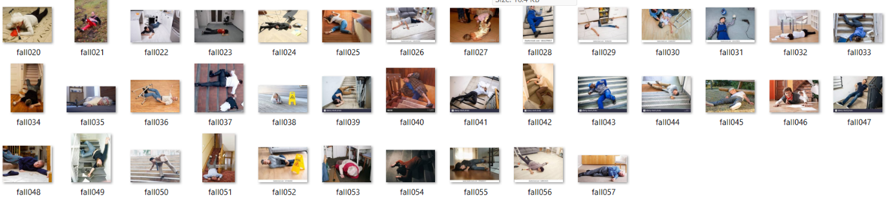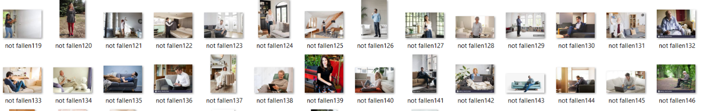
Training Dataset
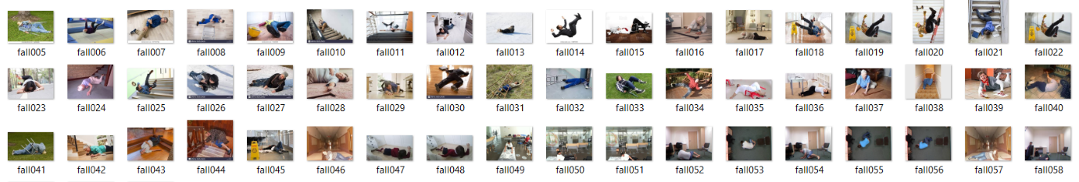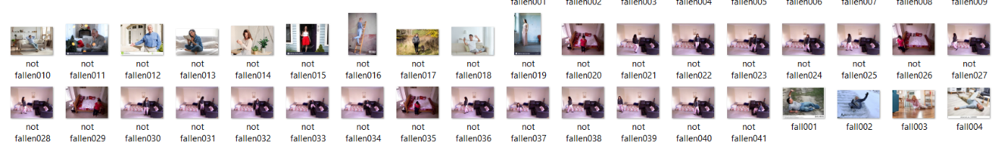
Validation Dataset

2. Detection Module Phase
Objective: Detect humans in real-time frames using YOLOv11m.
- Input: Live video feed or video file.
- Tools: YOLOv11m, OpenCV.
- Process:
  - Load YOLOv11m weights trained on the dataset.
  - Detect persons in the video stream.
  - Draw bounding boxes.
- Output: Detected person(s) per frame with coordinates.
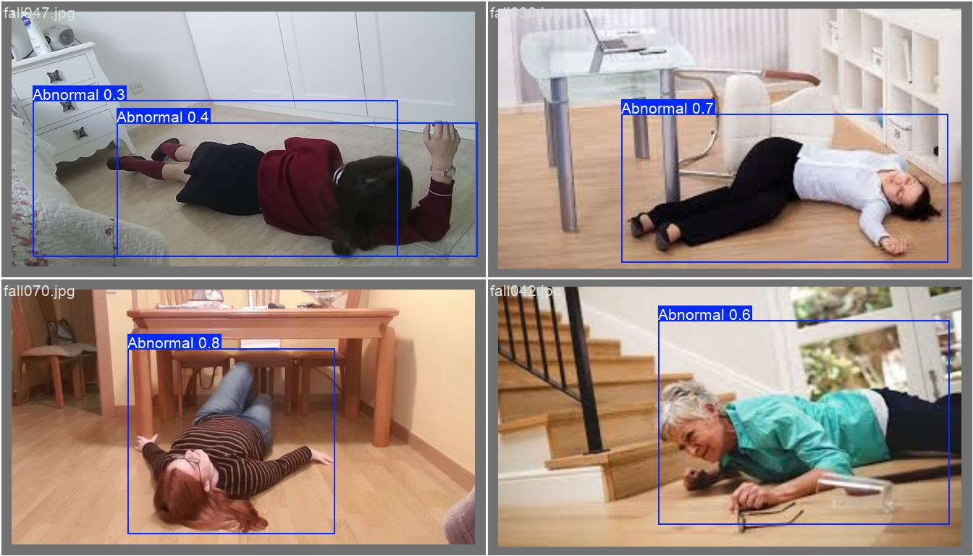
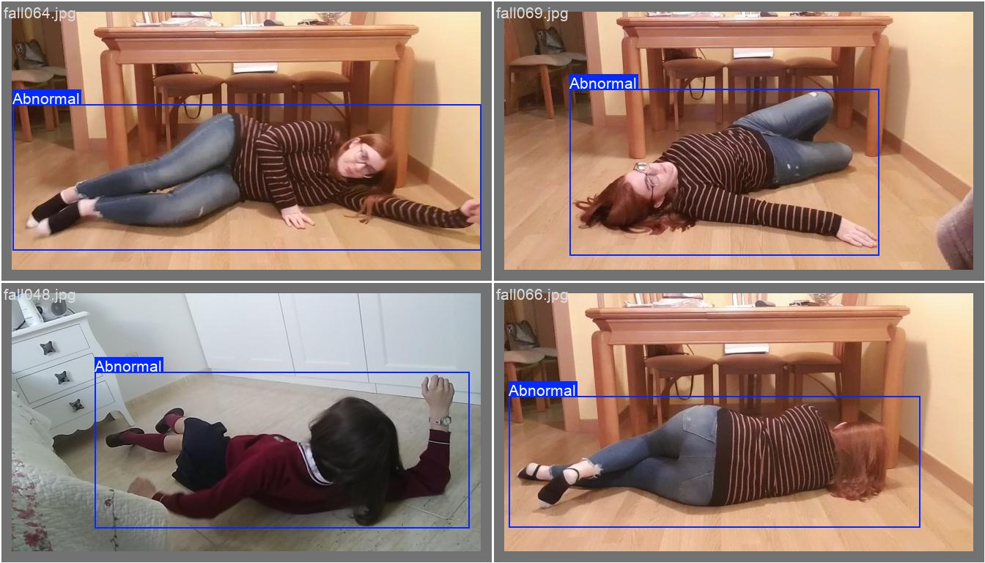
3. Pose Estimation Phase
Objective: Identify key body joints using MediaPipe.
- Input: Frames from YOLO output.
- Tools: MediaPipe Pose.
- Process:
  - Extract 33 key points from detected humans.
  - Track posture changes.
- Output: Pose landmarks per person per frame.
4. Classification Phase
Objective: Classify behavior as "Normal" or "Abnormal (Fall)".
- Input: Pose landmarks.
- Tools: Custom logic or ML classifier (e.g., SVM, rule-based).
- Process:
  - Analyze joint angles and positions.
  - Use rules or trained model to classify posture.
- Output: Label as “Fall” or “Normal”.
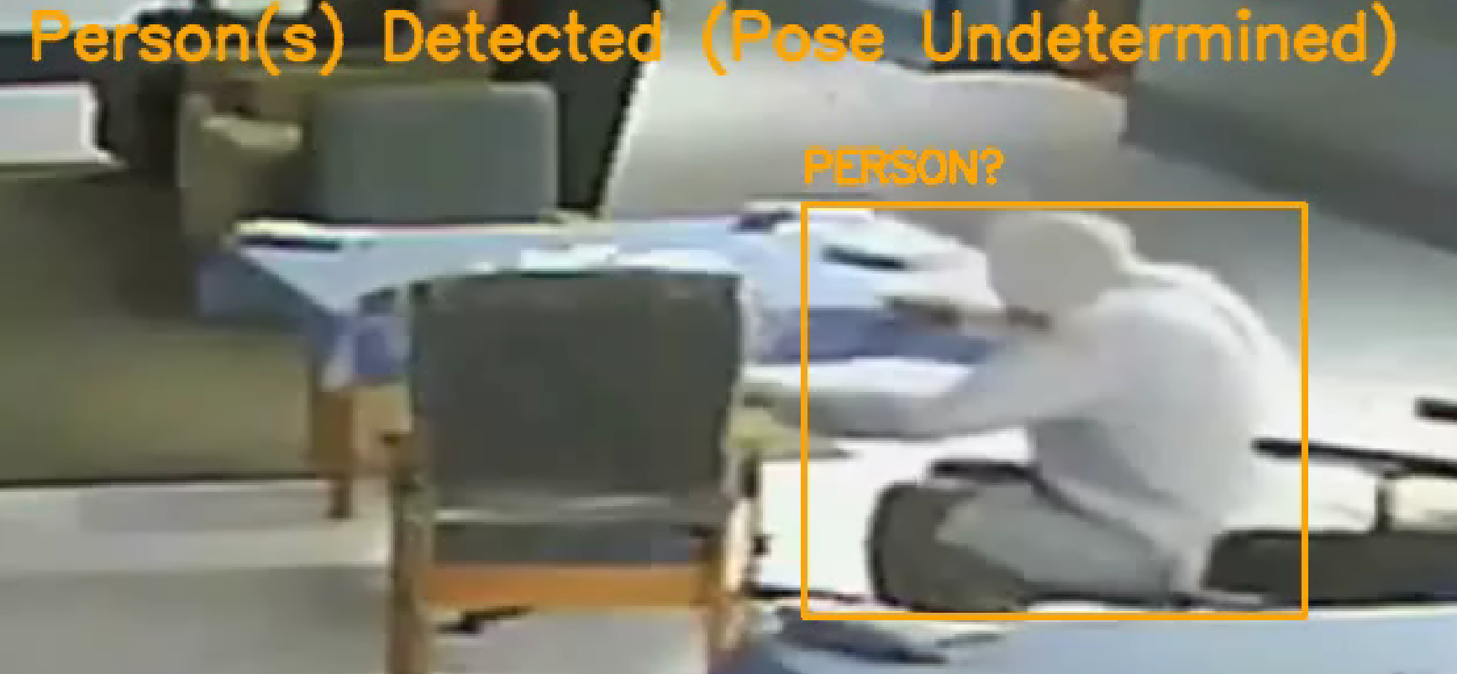

5. Alert System Module
Objective: Trigger alert if abnormality is detected.
- Input: Classified output (Fall).
- Process:
  - Generate alert overlay (e.g., “FALL DETECTED” text on frame).
- Output: Visual alert on processed video.

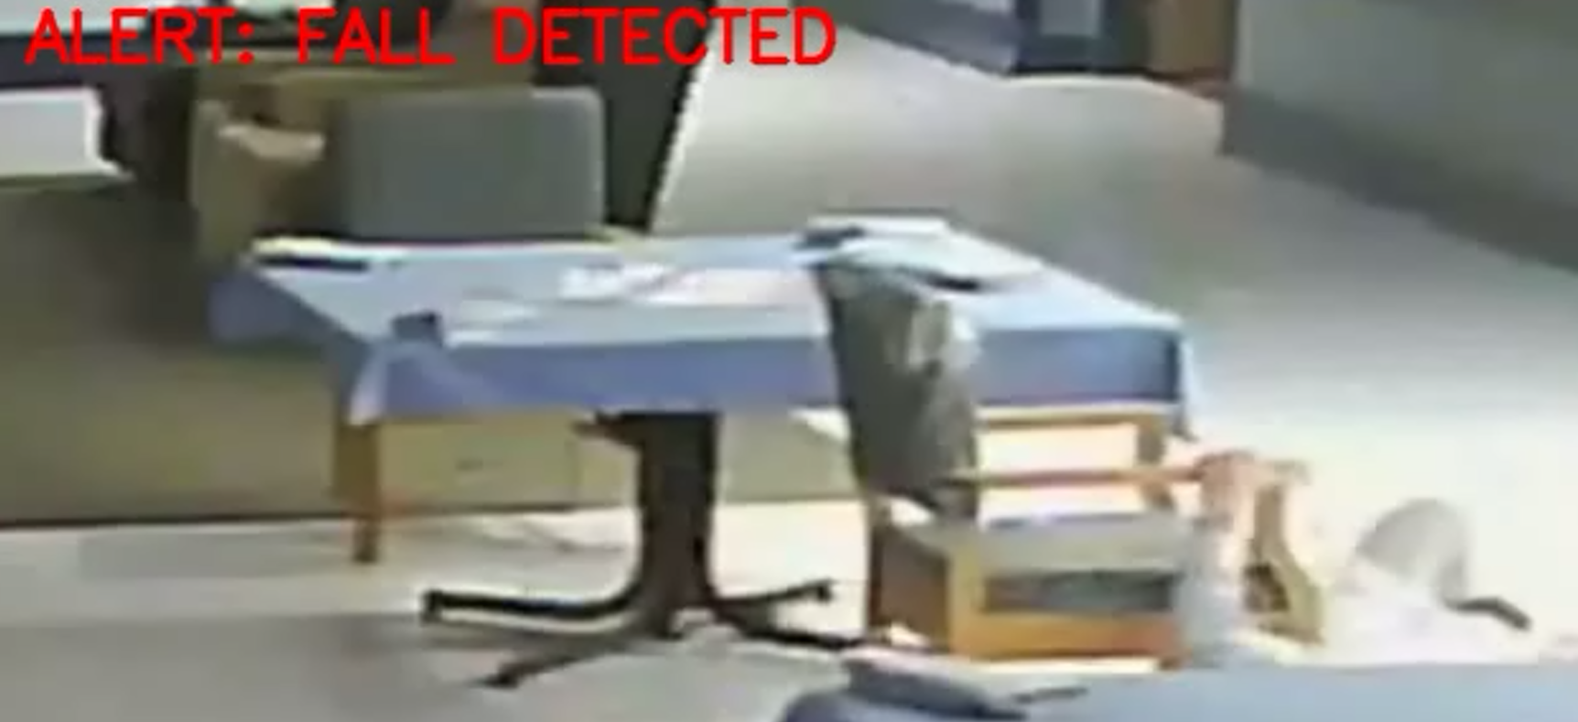

6. Updated Streamlit UI Module
Objective: Provide interface to upload/process videos and download results.
- Input: Uploaded video file from user.
- Process:
  - Display progress bar or processing status.
  - Run detection → pose → classification → alert overlays.
  - Save output video with detection boxes and labels.
- Output:
  - Streamed preview of processed video.
  - Downloadable output video (processed_output.mp4).
